TIPS FOR LOCALIZING

***FOR MARKETS: Consider swapping one of the below destinations and accommodations for a local one, based on desk research on resorts to ensure the pitch is relevant for your market.

As always, please share content with your Regional Lead for final approval***

Booking.com Shares Six Tranquil Escapes for Global Wellness Day

With Booking.com’s latest research revealing that over three-quarters (78%) of travelers want to mentally unwind on vacation to boost their mood,* it’s clear that travel for self-care is still firmly high on the agenda. To celebrate Global Wellness Day, a day dedicated to living well and reducing everyday stresses on 11 June, Booking.com has delved into its more than 28 million reported listings (including 6.4 million instantly bookable homes, apartments and other unique places to stay) to select six of the best resorts to help travelers find peace of mind. From the far-reaching desert in Chile to the Indian Ocean in Mauritius, travelers can pick their perfect spot across the globe for a serene escape that will allow some good rest and relaxation.

Byron Bay, Australia
This beachside town is perfect for those seeking sun, sea, sand and serenity. The sustainably minded Crystalbrook Byron (formerly Byron at Byron) is a must-visit. Set amongst 18 hectares of land, this luscious resort is great for those looking to relax their body and mind and immerse themselves in nature with free daily outdoor yoga classes and endless trails through the surrounding rainforest. Travelers can take a trip on a relaxing Brunswick River Sunset Eco Cruise to discover Byron’s wildlife and marine creatures, before heading back to enjoy a succulent dinner at the onsite Forest restaurant where 80% of the ingredients are sourced locally including delicious sustainably-sourced seafood.
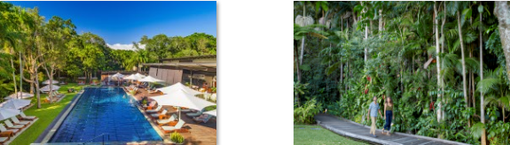

Northern California, United States
With Booking.com research revealing that half (51%) of travelers globally want to try out the best places for food and drink on their next vacation,** wine region Napa Valley should definitely top the bucket list. There are a plethora of luxury resorts to ensure travelers experience a tranquil trip, including the elegant Auberge du Soleil, An Auberge Resort. Nestled among a 33-acre olive grove, the resort features 50 rooms and suites, offers tailored wine tasting classes and is home to Napa Valley’s first fine-dining restaurant. Guests can unwind at the outdoor pool on one of the cabanas, take in the surrounding views with a hike through the hills or restore inner balance with a visit to La Pagode, the hotel’s Japanese-inspired wellness center, secluded within the expansive outdoor sculpture garden.
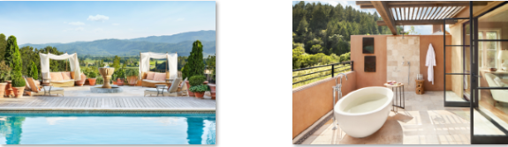

Bressanone, Italy
Also known as ‘Brixen,’ Bressanone is one of the oldest towns in South Tyrol, a province in the northeast of Italy, and the perfect destination for travelers who are seeking a mixture of culture and relaxation. Staying at the boutique wellness resort Forestis Dolomites will put travelers in a prime spot to enjoy the panoramic views of the Dolomites mountains, a UNESCO World Heritage site. Secluded on the southern slope of the Plose mountain in the South Tyrolean Alps, this family-run hotel features a large spa where guests can indulge in mountain pine body scrubs or forest salt baths, and an onsite restaurant with freshly sourced ingredients from local farmers. With magnificent views overlooking the surrounding forests through floor-to-ceiling windows, the hotel also offers a range of experiences intended to benefit the body, mind and soul including snowshoe hiking in the winter and forest yoga in the summer.
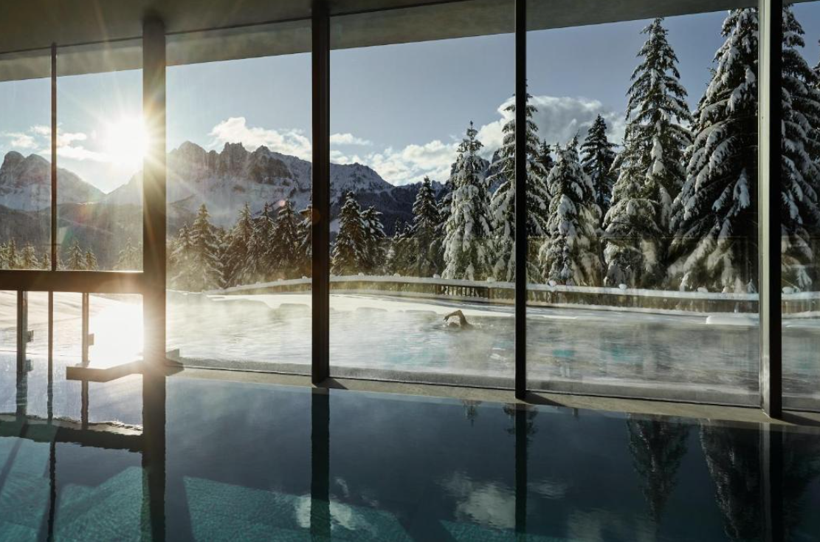 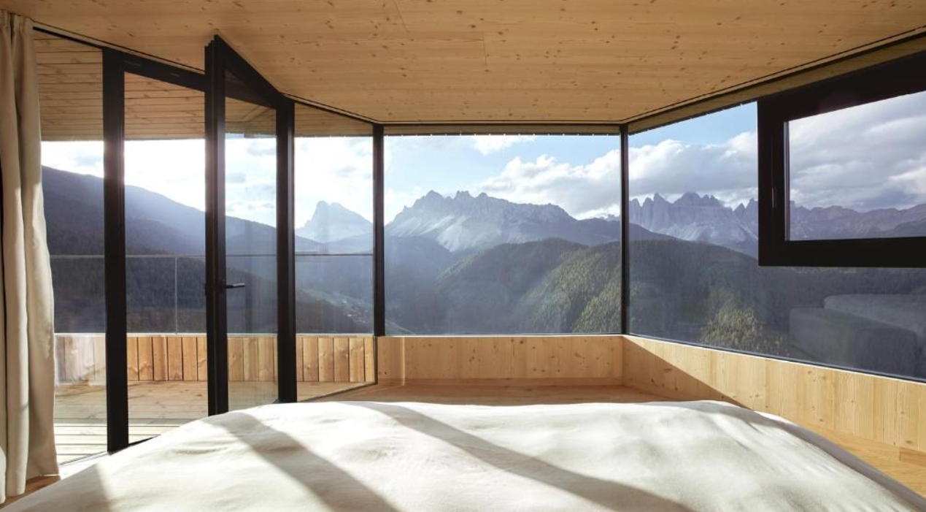

Dibba, Oman
Mountain peaks, stunning landscapes and crystal clear waters make Dibba the ultimate destination for those wanting to unwind in nature. Facing the Arabian Sea the Six Senses Zighy Bay has the best of both worlds when it comes to calming views, with mountains on one side and a stunning private beach on the other. This village-style, Travel Sustainable resort offers luxury villas with private pools and a comprehensive spa and wellness center including blissful Moroccan hammams.
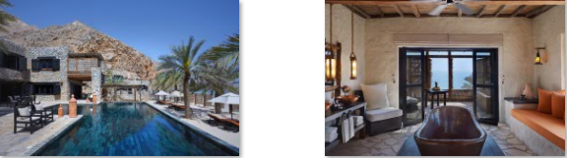

Krabi, Thailand
Luxurious and set within tropical gardens the Phulay Bay, A Ritz-Carlton Reserve is the perfect stay to help travelers get away from the hustle and bustle of city life. Located along the shores of the Andaman Sea, the resort features chic, traditional accommodation with a luxury spa and pool. For guests looking to try something new, there’s a range of unique cultural experiences on offer including Thai cooking and batik painting lessons. The resort also holds a Booking.com Travel Sustainable badge for its robust sustainability measures. Visitors can head out to Wareerak Hot Springs, known for its soothing and therapeutic mineral-rich springs – the perfect place to unwind and soak up the healing properties of the water, surrounded by jungle.
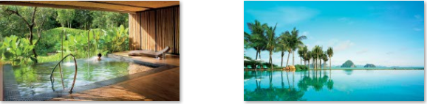

Cap Malheureux, Mauritius
Famous for its blue waters and white sands, Mauritius is an iconic destination for both a tranquil and a luxury escape. Located on the northern coast, Cap Malheureux is home to the idyllic Paradise Cove Boutique Hotel. This adults-only resort is located directly on a private beach and features a lush tropical garden with an infinity pool, a choice of four restaurants and bars, a spa and a number of activities including snorkeling and a glass-bottom boat tour. Both serenity and sustainability are at the core of this resort, which has earned a Travel Sustainable badge for its efforts around protecting the environment as well as supporting the economy and local community.
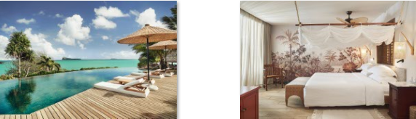

For those travelers who are up for relaxation and to mentally unwind, Booking.com is sharing Getaway Deals for travelers to use when booking their next trip. Discounts start at 15 percent at participating properties indicated by the “Getaway 2022” badge, and are valid for stays with check-out on or before 30 September 2022. In addition, Booking.com is giving travelers around the world the keys to unlock a new level of additional perks with the introduction of a third tier to its Genius loyalty program. Designed to make every trip a better experience, Booking.com’s loyalty program is completely free, easily accessible and membership lasts a lifetime – travelers simply need to create an account to achieve Genius status for life. As Genius members unlock new levels, they get access to larger discounts and more travel rewards that never expire. All travelers have to do is sign into their Booking.com account and look for the Genius logo to identify benefits, discounts and perks.

*Research commissioned by Booking.com and independently conducted among a sample of 48,413 respondents across 31 markets (2,000 from USA, 1,864 from Canada, 1,999 from Mexico, 2,003 from Colombia, 2,005 from Brazil, 2,002 from Argentina, 1,020 from Chile, 1,777 from Australia, 818 from New Zealand, 1,999 from Spain, 2,002 from Italy, 1,998 from France, 1,990 from UK, 2,005 from Germany, 2,003 from Netherlands, 985 from Denmark, 999 from Sweden, 910 from Croatia, 918 from Switzerland, 1,986 from Belgium, 998 from Russia, 953 from Israel, 1,999 from India, 1,990 from China, 901 from Hong Kong, 1,775 from Thailand, 1,001 from Singapore, 975 from Taiwan, 1,800 from Vietnam, 1,757 from South Korea, 1,001 from Japan). In order to participate in this survey, respondents had to be 18 years of age or older, had to have traveled at least once for business or leisure in the past 12 months, and planning to travel in 2022 and be either the primary decision maker or involved in the decision making of their travel. The survey was taken online and took place in January 2022.

**Research commissioned by Booking.com and conducted among a sample of adults who plan to travel for business or leisure in the next 12-24 months. In total 24,055 respondents across 31 countries and territories were polled (including 501 from Argentina, 1003 from Australia, 500 from Belgium, 1001 from Brazil, 500 from Canada, 1000 from China, 1007 from Colombia, 1001 from Croatia, 508 from Denmark, 1002 from France, 1000 from Germany, 1005 from Hong Kong, 1000 from India, 502 from Israel, 1003 from Italy, 1002 from Japan, 500 from Mexico, 501 from The Netherlands, 501 from New Zealand, 500 from Peru, 1000 from Russia, 1005 from Singapore, 1002 from South Korea, 1002 from Spain, 501 from Sweden, 501 from Switzerland, 504 from Taiwan, 500 from Thailand, 1000 from the UK, 1002 from the US and 501 from Vietnam). Respondents completed an online survey in August 2021.

